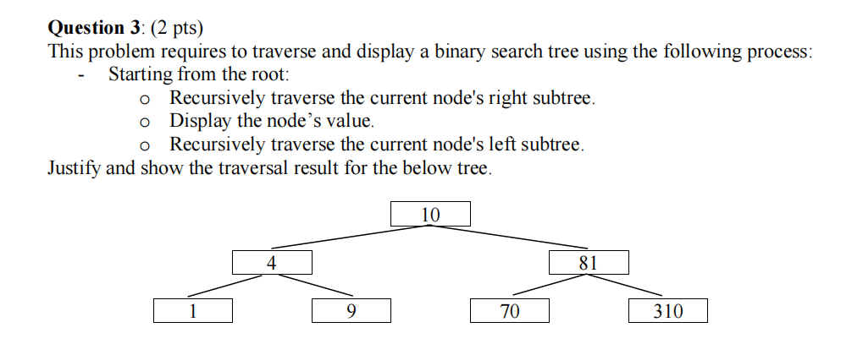
Question 3:
Start from node 10,
Traverse the right node of 10 is 81
Traverse the right node of 81 is 310
Print: 310
Turn back to 81 print 81
Traverse the left node of 81 is 70
Print70
Turn back to 10
Print 10
Traverse the left node of 10 is 4

Traverse the right node of 4 is 9
Print 9
Turn back to 4
Print 4
Traverse the left node of 4 is 1
Print 1
310 - 81 - 70 - 10 - 9 - 4 - 1

